# Progress Test 2

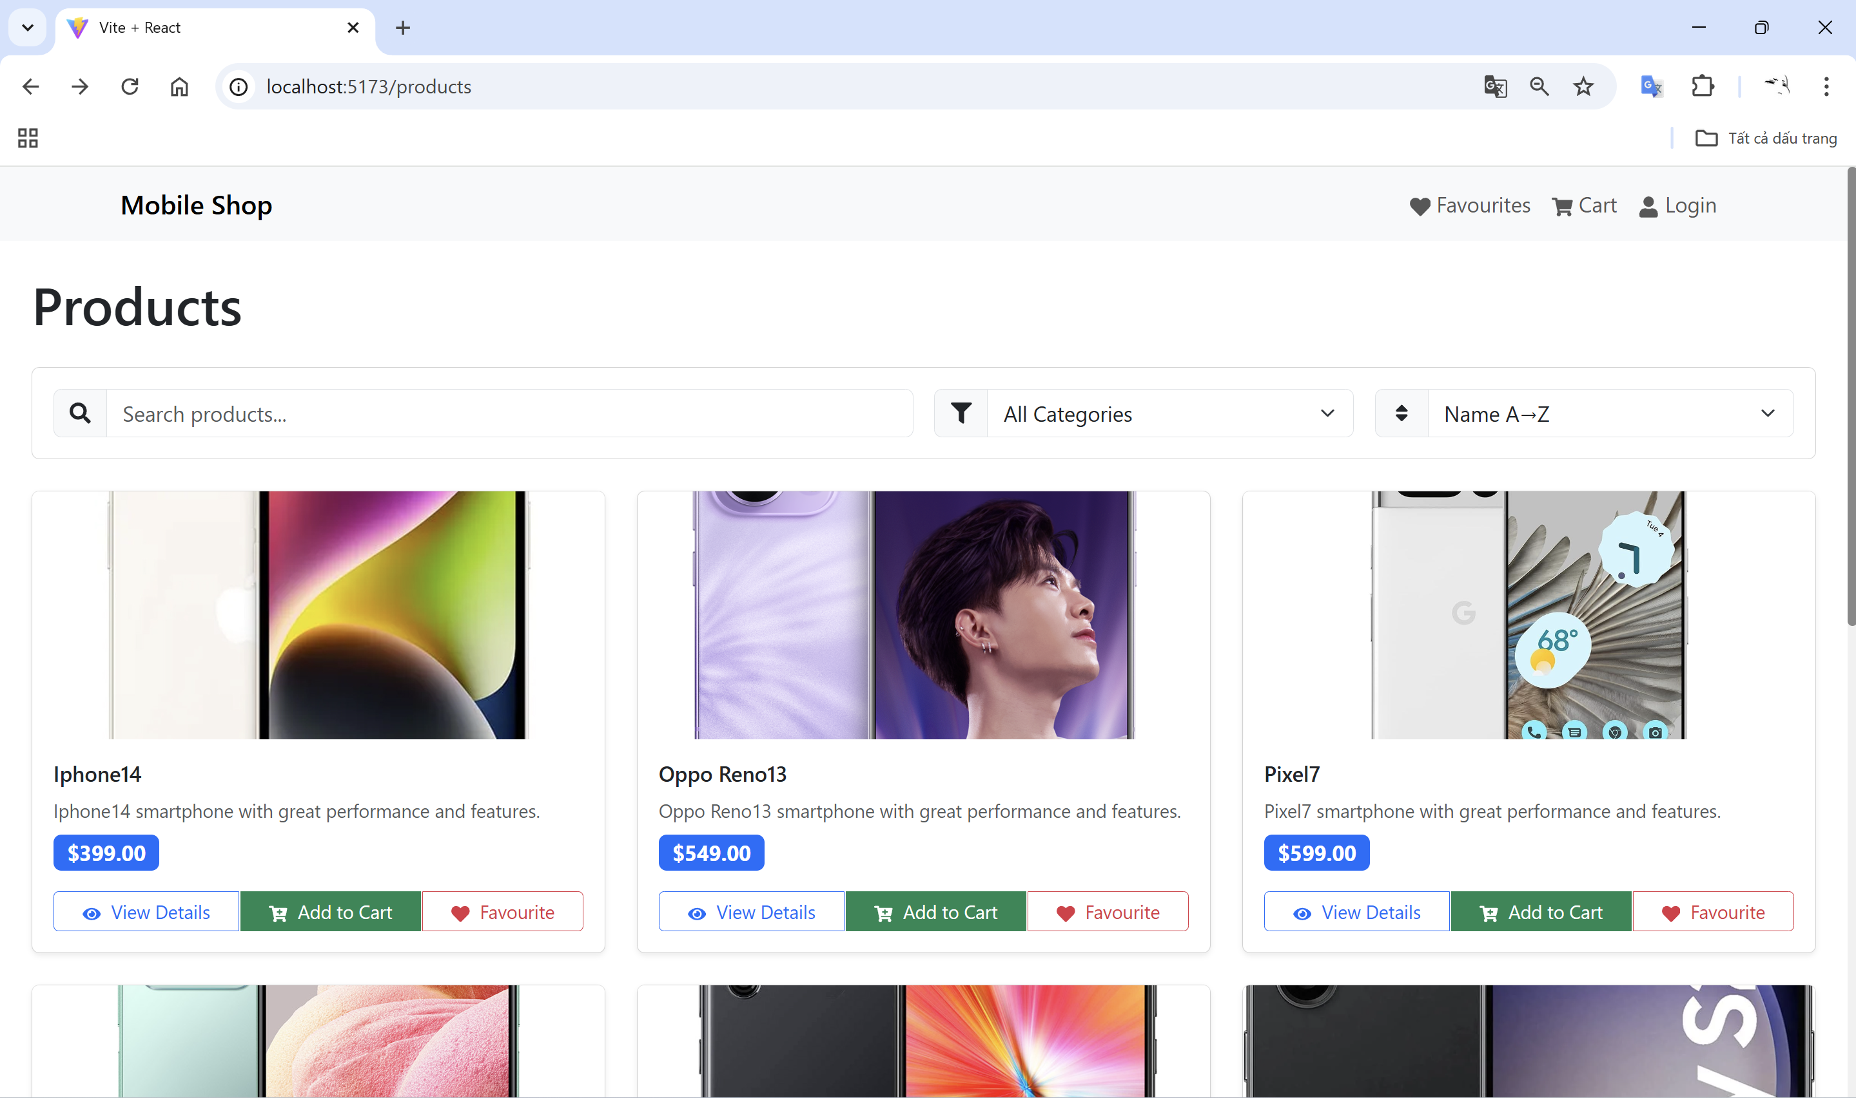

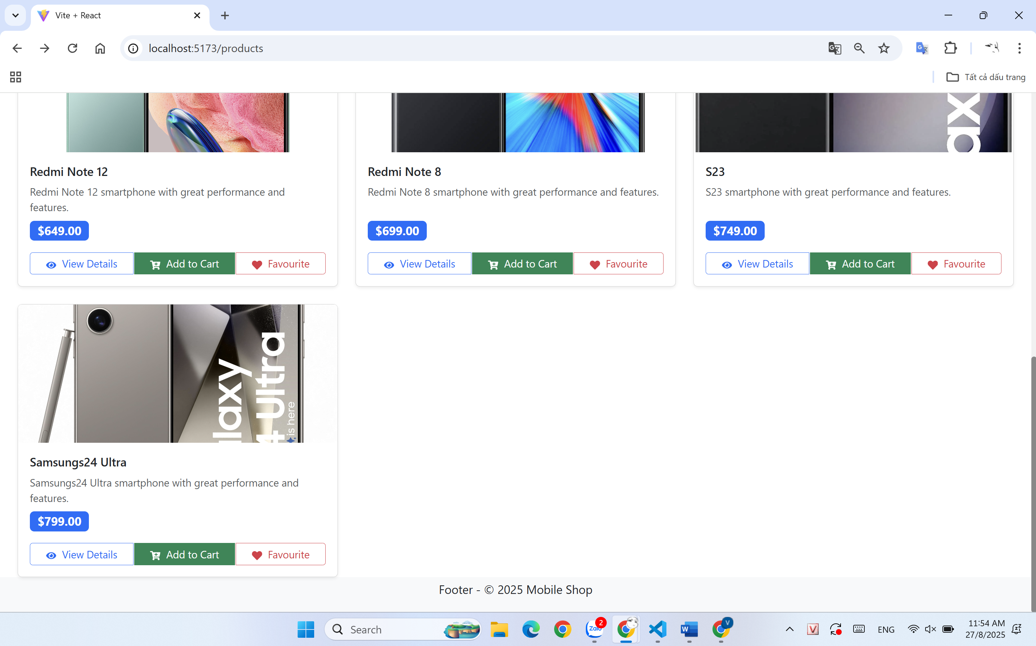

## ProductsPage.jsx

import React, { useEffect, useState } from 'react';

import { Container, Row, Col, Form, InputGroup, Button, Card } from 'react-bootstrap';

import { FaSearch, FaTimesCircle, FaFilter, FaSort } from 'react-icons/fa';

import NavBar from '../components/NavBar';

import ProductCard from '../components/ProductCard';

import { useProductFilters } from '../hooks/useProductFilters';

import api from '../services/api';

export default function ProductsPage() {

  const [searchQuery, setSearchQuery] = useState('');

  const [sortBy, setSortBy] = useState('newest');

  const [filterBy, setFilterBy] = useState('all');

  const [products, setProducts] = useState([]);

  useEffect(() => {

    (async () => {

      const { data } = await api.get('/products');

      const normalized = (data || []).map(p => ({

        id: p.id,

        name: p.title || p.name,

        image: p.image,

        price: p.price,

        description: p.description,

        category: p.category

      }));

      setProducts(normalized);

    })();

  }, []);

  const filteredProducts = useProductFilters(products, searchQuery, sortBy, filterBy);

  return (

    <div className="d-flex flex-column min-vh-100">

      <NavBar />

      <Container fluid className="flex-grow-1 px-4">

        <h1 className="mb-4">Products</h1>

        <Card className="mb-4">

          <Card.Body>

            <Row className="g-3">

              <Col md={6}>

                <InputGroup>

                  <InputGroup.Text><FaSearch /></InputGroup.Text>

                  <Form.Control

                    placeholder="Search products..."

                    value={searchQuery}

                    onChange={(e) => setSearchQuery(e.target.value)}

                  />

                  {searchQuery && (

                    <Button variant="outline-secondary" onClick={() => setSearchQuery('')}>

                      <FaTimesCircle />

                    </Button>

                  )}

                </InputGroup>

              </Col>

              <Col md={3}>

                <InputGroup>

                  <InputGroup.Text><FaFilter /></InputGroup.Text>

                  <Form.Select value={filterBy} onChange={(e) => setFilterBy(e.target.value)}>

                    <option value="all">All Categories</option>

                    <option value="iphone">iPhone</option>

                    <option value="samsung">Samsung</option>

                    <option value="google">Google</option>

                    <option value="oppo">Oppo</option>

                  </Form.Select>

                </InputGroup>

              </Col>

              <Col md={3}>

                <InputGroup>

                  <InputGroup.Text><FaSort /></InputGroup.Text>

                  <Form.Select value={sortBy} onChange={(e) => setSortBy(e.target.value)}>

                    <option value="name-asc">Name A→Z</option>

                    <option value="name-desc">Name Z→A</option>

                    <option value="price-asc">Price ↑</option>

                    <option value="price-desc">Price ↓</option>

                  </Form.Select>

                </InputGroup>

              </Col>

            </Row>

          </Card.Body>

        </Card>

        <Row className="g-4">

          {filteredProducts.map(p => (

            <Col key={p.id} xs={12} sm={6} md={4}>

              <ProductCard product={p} />

            </Col>

          ))}

        </Row>

        {filteredProducts.length === 0 && (

          <Row className="mt-4"><Col><Card className="text-center"><Card.Body>No mobile found.</Card.Body></Card></Col></Row>

        )}

      </Container>

    </div>

  );

}

## ProductDetails.jsx

import React, { useEffect, useState } from 'react';

import { useParams, useNavigate } from 'react-router-dom';

import { Container, Row, Col, Card, Button } from 'react-bootstrap';

import api from '../services/api';

import { formatPrice } from '../utils/format';

export default function ProductDetails() {

  const { id } = useParams();

  const navigate = useNavigate();

  const [product, setProduct] = useState(null);

  useEffect(() => {

    (async () => {

      try {

        const { data } = await api.get(`/products/${id}`);

        setProduct({

          id: data.id,

          name: data.name,

          image: data.image,

          price: data.price,

          description: data.description,

          category: data.category

        });

      } catch (error) {

        console.error('Error fetching product', error);

      }

    })();

  }, [id]);

  if (!product) return <Container className="py-4"><h3>Loading...</h3></Container>;

  return (

    <Container className="py-4">

      <Button variant="secondary" onClick={() => navigate('/products')} className="mb-3">Back to Products</Button>

      <Card>

        <Row>

          <Col md={6}>

            <Card.Img src={product.image} alt={product.name} style={{ objectFit: 'cover' }} />

          </Col>

          <Col md={6}>

            <Card.Body>

              <Card.Title>{product.name}</Card.Title>

              <Card.Text>{product.description}</Card.Text>

              <Card.Text>{formatPrice(product.price)}</Card.Text>

              <Button variant="success">Add to Cart</Button>

              <Button variant="outline-danger" className="ms-2">Favourite</Button>

            </Card.Body>

          </Col>

        </Row>

      </Card>

    </Container>

  );

}

## Login.jsx

import React, { useState } from 'react';

import { Container, Form, Button, Alert } from 'react-bootstrap';

import { useNavigate } from 'react-router-dom';

import api from '../services/api';

export default function LoginPage() {

  const [email, setEmail] = useState('');

  const [password, setPassword] = useState('');

  const [error, setError] = useState('');

  const navigate = useNavigate();

  const handleSubmit = async (e) => {

    e.preventDefault();

    try {

      const { data } = await api.get('/accounts');

      const user = data.find(u => u.email === email && u.password === password && u.isActive);

      if (user) {

        alert('Đăng nhập thành công!');

        navigate('/products');

      } else {

        setError('Email hoặc mật khẩu không đúng hoặc tài khoản không hoạt động');

      }

    } catch (err) {

      setError('Lỗi khi đăng nhập');

    }

  };

  return (

    <Container fluid className="py-4 bg-light min-vh-100 d-flex justify-content-center align-items-center">

      <div className="w-100" style={{ maxWidth: '400px' }}>

        <h2 className="text-center mb-4">Đăng nhập</h2>

        <Form onSubmit={handleSubmit}>

          <Form.Group className="mb-3">

            <Form.Label>Email</Form.Label>

            <Form.Control

              type="email"

              value={email}

              onChange={(e) => setEmail(e.target.value)}

              required

            />

          </Form.Group>

          <Form.Group className="mb-3">

            <Form.Label>Mật khẩu</Form.Label>

            <Form.Control

              type="password"

              value={password}

              onChange={(e) => setPassword(e.target.value)}

              required

            />

          </Form.Group>

          {error && <Alert variant="danger">{error}</Alert>}

          <Button type="submit" variant="primary" className="w-100">Đăng nhập</Button>

        </Form>

      </div>

    </Container>

  );

}

## Favourites.jsx

import React from 'react';

import { Container, Row, Col, Card, Button } from 'react-bootstrap';

import { useNavigate } from 'react-router-dom';

import { useCart } from '../Context/CartContext';

import { formatPrice } from '../utils/format';

export default function Favourites() {

  const { favourites, removeFromFavourites } = useCart();

  const navigate = useNavigate();

  return (

    <Container className="py-4">

      <h1 className="mb-4">Sản phẩm yêu thích</h1>

      {favourites.length === 0 ? (

        <Card><Card.Body>Không có sản phẩm yêu thích.</Card.Body></Card>

      ) : (

        <Row className="g-4">

          {favourites.map(item => (

            <Col key={item.id} md={4}>

              <Card>

                <Card.Img variant="top" src={item.image} alt={item.name} style={{ height: '150px', objectFit: 'cover' }} />

                <Card.Body>

                  <Card.Title>{item.name}</Card.Title>

                  <Card.Text>{formatPrice(item.price)}</Card.Text>

                  <Button variant="danger" onClick={() => removeFromFavourites(item.id)}>Xóa</Button>

                </Card.Body>

              </Card>

            </Col>

          ))}

        </Row>

      )}

    </Container>

  );

}

## Cart.jsx

import React from 'react';

import { Container, Row, Col, Card, Button } from 'react-bootstrap';

import { useNavigate } from 'react-router-dom';

import { useCart } from '../Context/CartContext';

import { formatPrice } from '../utils/format';

export default function Cart() {

  const { cart, removeFromCart } = useCart();

  const navigate = useNavigate();

  const total = cart.reduce((sum, item) => sum + item.price, 0);

  return (

    <div style={{

      display: 'flex',

      flexDirection: 'column',

      minHeight: '100vh',

      backgroundColor: '#f8f9fa',

      width: '100%',

      margin: 0,

      padding: 0

    }}>

      {/* Main Content */}

      <main style={{

        flex: 1,

        padding: '20px 0',

        width: '100%'

      }}>

        <Container fluid style={{ padding: '0 15px', maxWidth: '100%' }}>

          <h1 className="mb-4">Giỏ hàng</h1>

          {cart.length === 0 ? (

            <Card><Card.Body>Không có sản phẩm trong giỏ hàng.</Card.Body></Card>

          ) : (

            <>

              <Row className="g-4">

                {cart.map(item => (

                  <Col key={item.id} md={4}>

                    <Card>

                      <Card.Img variant="top" src={item.image} alt={item.name} style={{ height: '150px', objectFit: 'cover' }} />

                      <Card.Body>

                        <Card.Title>{item.name}</Card.Title>

                        <Card.Text>{formatPrice(item.price)}</Card.Text>

                        <Button variant="danger" onClick={() => removeFromCart(item.id)}>Xóa</Button>

                      </Card.Body>

                    </Card>

                  </Col>

                ))}

              </Row>

              <div className="mt-4">

                <h4>Tổng cộng: {formatPrice(total)}</h4>

                <Button variant="success" onClick={() => navigate('/checkout')}>Thanh toán</Button>

              </div>

            </>

          )}

        </Container>

      </main>

    </div>

  );

}

## ProductCard.jsx

import React from 'react';

import { useNavigate } from 'react-router-dom';

import { Card, Button, Badge, ButtonGroup } from 'react-bootstrap';

import { FaEye, FaCartPlus, FaHeart } from 'react-icons/fa';

import { formatPrice, assetUrl } from '../utils/format';

import { useCart } from '../Context/CartContext';

const ProductCard = ({ product }) => {

  const navigate = useNavigate();

  const { addToCart, addToFavourites } = useCart();

  return (

    <Card className="h-100 shadow-sm product-card">

      <Card.Img

        variant="top"

        src={assetUrl(product.image)}

        alt={product.name}

        style={{ height: '200px', objectFit: 'cover' }}

      />

      <Card.Body className="d-flex flex-column">

        <Card.Title className="h6 mb-2">{product.name}</Card.Title>

        <Card.Text className="flex-grow-1 small text-muted mb-2">

          {product.description}

        </Card.Text>

        <div className="mb-3">

          <Badge bg="primary" className="fs-6">

            {formatPrice(product.price)}

          </Badge>

        </div>

        <ButtonGroup className="w-100">

          <Button

            variant="outline-primary"

            size="sm"

            className="flex-fill"

            onClick={() => navigate(`/products/${product.id}`)}

          >

            <FaEye className="me-1" /> View Details

          </Button>

          <Button

            variant="success"

            size="sm"

            className="flex-fill"

            onClick={() => addToCart(product)}

          >

            <FaCartPlus className="me-1" /> Add to Cart

          </Button>

          <Button

            variant="outline-danger"

            size="sm"

            className="flex-fill"

            onClick={() => addToFavourites(product)}

          >

            <FaHeart className="me-1" /> Favourite

          </Button>

        </ButtonGroup>

      </Card.Body>

    </Card>

  );

};

export default ProductCard;

## NavBar.jsx

import React from 'react';

import { Navbar, Nav, Container } from 'react-bootstrap';

import { FaHeart, FaShoppingCart, FaUser } from 'react-icons/fa';

import { Link } from 'react-router-dom';

const NavBar = () => {

  return (

    <Navbar bg="light" expand="lg" className="mb-4">

      <Container>

        <Navbar.Brand as={Link} to="/products">Mobile Shop</Navbar.Brand>

        <Navbar.Toggle aria-controls="basic-navbar-nav" />

        <Navbar.Collapse id="basic-navbar-nav">

          <Nav className="ms-auto">

            <Nav.Link as={Link} to="/favourites"><FaHeart /> Favourites</Nav.Link>

            <Nav.Link as={Link} to="/cart"><FaShoppingCart /> Cart</Nav.Link>

            <Nav.Link as={Link} to="/login"><FaUser /> Login</Nav.Link>

          </Nav>

        </Navbar.Collapse>

      </Container>

    </Navbar>

  );

};

export default NavBar;

## CartContext.jsx

import React, { createContext, useContext, useState } from 'react';

const CartContext = createContext();

export function CartProvider({ children }) {

  const [cart, setCart] = useState([]);

  const [favourites, setFavourites] = useState([]);

  const addToCart = (product) => {

    setCart([...cart, product]);

  };

  const addToFavourites = (product) => {

    setFavourites([...favourites, product]);

  };

  const removeFromCart = (id) => {

    setCart(cart.filter(item => item.id !== id));

  };

  const removeFromFavourites = (id) => {

    setFavourites(favourites.filter(item => item.id !== id));

  };

  return (

    <CartContext.Provider value={{ cart, favourites, addToCart, addToFavourites, removeFromCart, removeFromFavourites }}>

      {children}

    </CartContext.Provider>

  );

}

export const useCart = () => useContext(CartContext);